|  |
| --- |
| TALKBOX  USER MANUAL |
|  |
| **February 24**, 2019  **VERSION 1.0**  **GROUP 9**  **Authored by: Neharika Puri, Eric Pham, Yonis Abokar** |

TABLE OF CONTENTS

1. Introduction …………………………………………………………………………………………………………… 3
2. Functionality ………………………………………………………………………………………………………….. 3
3. System Requirement ……………………………………………………………………………………………… 3
4. How to get started ………………………………………………………………………………………………… 4
   1. Download as JAR..……………………………………………………………………………………… 4
   2. Open in an IDE…………………………………………………………………………………………….. 4
5. Configuration App ………………………………………………………………………………………………….. 4
   1. Create a Button………………………………………………………………………………………….. 5
   2. Make a Profile ……………………………………………………………………………………………..5
   3. Record Audio………………………………………………………………………………………………..6
   4. Add Recordings to Button …………………………………………………………………………….6
   5. Import Audio File ………………………………………………………………………………………….7
   6. Launch your Profile………………………………………………………………………………………..7
   7. Load Profile…………………………………………………………………………………………………..8
6. Simulator App ……………….……………………………………………………………………………………….. 8
   1. Use the buttons and hear audio ………………………………………………………………… 9
7. Help
   1. Help with JAR……………………………………………………………………………………………..9
   2. Help with IDE………………………………………………………………………………………………10
8. **Introduction**

The purpose of this application is to virtually stimulate a TalkBox that will later be simulated on Raspberry Pie. The software in general will aid in communication for the users, who currently struggle with it due to the medical reasons. The overall layout is interactive and easy to use.

The software consists of two applications:

1. TalkBox Simulator
2. TalkBox Configuration

The configuration will provide the users with a GUI App environment and show different functionalities available.

The Simulator will provide the users with buttons (that they will have a freedom to create) that can be used to aid communication.

* 1. **Functionality**

The software provides the user with much more functionalities than a usual Sound Generating Device (SGD). Some of them are as follows:

* Choosing the number of buttons for your screen
* Making a profile
* Using Pre-recordings
* Record your personal audio/sound
* Adding recordings to the buttons
* Adding buttons to your profile
* Launching your profile, with named buttons

**3.0 System Requirement**

This software will operate on a desktop/laptop device. It will require a supporting Operating System (OS). Moreover, it will also require JRE 8 and higher versions. The basic use of the software will not require an internet connection, but accessing documentation might require a stable internet connection.

The hardware required will be a microphone to allow personal recordings. Also as this software is computer based and there is no hardware buttons the user will need a mouse to interact with the system.

**4.0 How to get started:**

**\*Preferred but optional steps**

**4.1 Download as a JAR**

*1. Create a directory to hold the JAR files

1. Go to https://github.com/neharikapurieng/TalkBox

2. Click, download the JAR

*3. Save jar to the directory made

3. Save it.

4. Go to saved location and extract TalkBoxConfiguration.(It should extract to new folder called TalkBoxConfiguration).

5. Open command Prompt or Terminal depending on operating system

6. Navigate to the directory holding the jar files

7. Type java -jar TalkBoxConfiguration.jar to run

**If unable to run, refer to section 7**

**4.2 Open in an IDE**

1. Go to https://github.com/neharikapurieng/TalkBox

2. Click, download the project.

3. Open an IDE of your choice, and open this project on it.

4. Run the project.

**If unable to run, refer to section 7**

**5.0 Configuration App**

1. When you run the application. The configuration app will display.

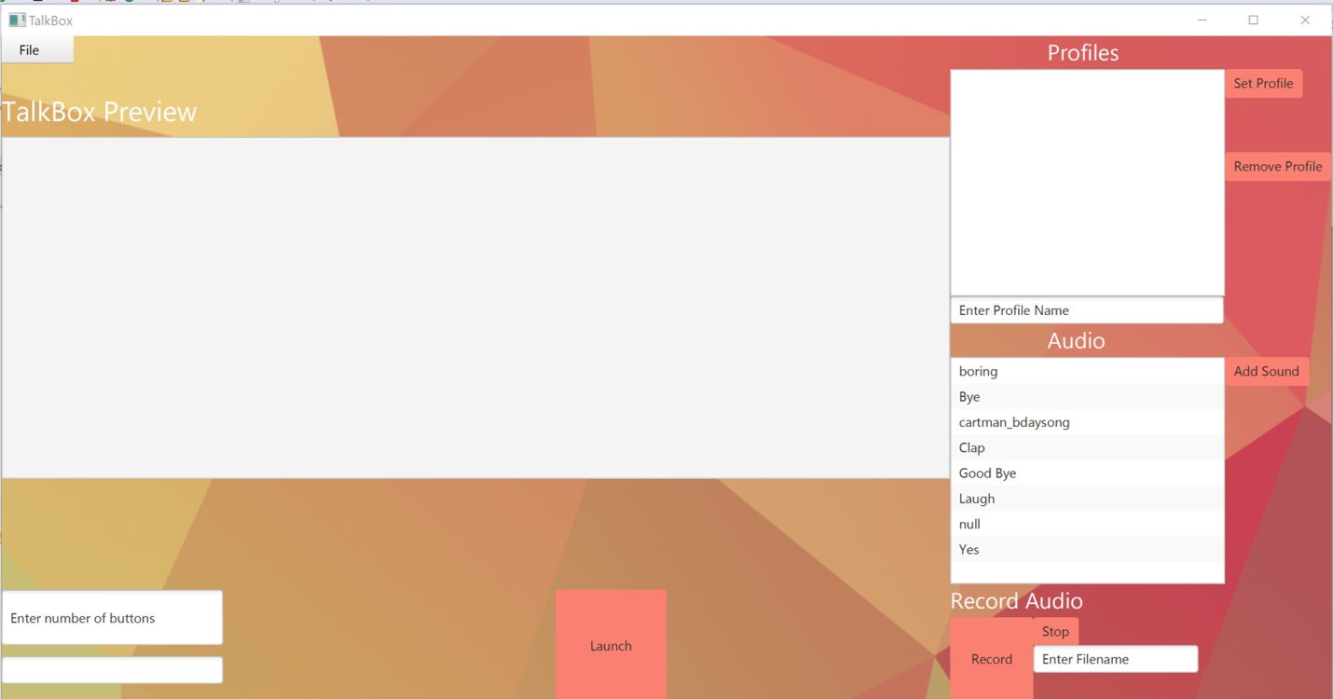

**5.1 Create a button**

1. On the bottom left side, click the box that says “Enter number of buttons”. Then type the number of buttons you want and press enter. The inputted number of buttons will display on the screen.

Notice these buttons don’t have a name yet. Do not worry, it will very soon.

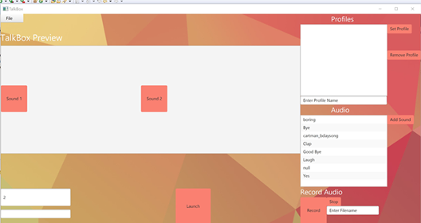

**5.2 Make a profile**

Now that you have your buttons, you need to make a profile. To do so, follow these steps.

1. On the top right corner, you will see a profile. Go to the box that says “Enter Profile Name”, in their write a profile name and pres enter.

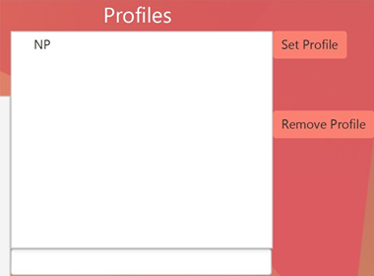

**5.3 Record Audio**

On the right bottom corner, you will see a list of pre-recorded audios. In order to record your own audio, follow the following steps and you will see your audio in the list.

1. Write a name of the audio, in the box that says “Enter Filename”. By clicking on the box and entering the name.
2. Press Record, and say what you want to, then press stop.

Your audio will be now on the list.

**5.4 Adding recording to the button**

Now that you have the recording you need, or you see it already in the list of pre-recordings. It’s time to add the recording in the button.

1. Choose the recording you want to add and press “Add Sound”.
2. You will see a little triangle appear on the left of your Profile Name, click the triangle and you will see all the recordings you added.
3. Press Set Profile and you see the name of the recordings, on your button now.

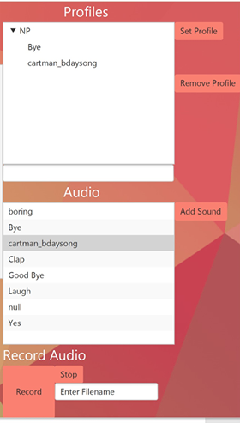

**5.5 Import Audio Files**

If you have wav files in your personal computer you can import them into the TalkBoxConfiguration to use them.

1. Click File
2. Click Import Audio
3. Navigate through personal directories
4. Add the wav file
5. The wav file should appear at the bottom of the list of audio files.

**5.6 Launch your profile**

Now, that your profile is ready. Press the button called “Launch”

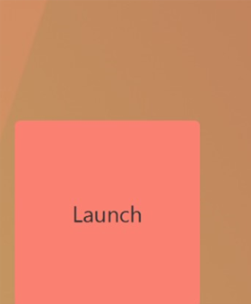

**5.7 Reload Profile**

After using the configurator and launching it once, you can go back and import the last configuration you had.

1)Click File

2) Click Load Profile

3) The profiles made from the last configuration should appear under “Profiles”

**6.0 Simulator App**

Now, that you have launched your profile. You will see another app opening. This is the simulator.

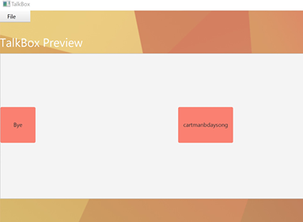

**6.1 Use the buttons and hear audio**

1. On the right side of this app, you will see your profile name. Under it, you will also see a Set Profile button, click this button and your buttons with the audio will appear.

2. Press any button you wish, and you will hear an audio. (ps. Make sure your speakers are on)

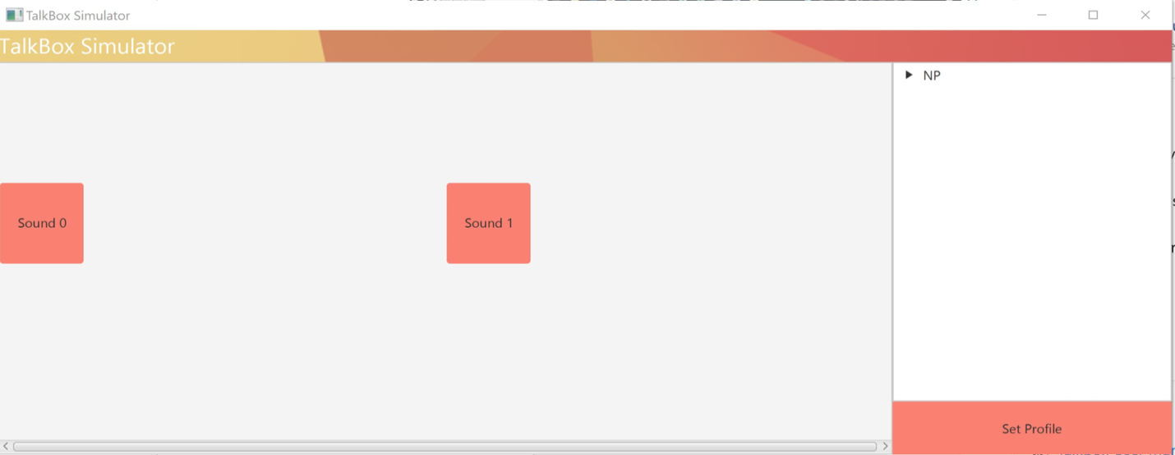

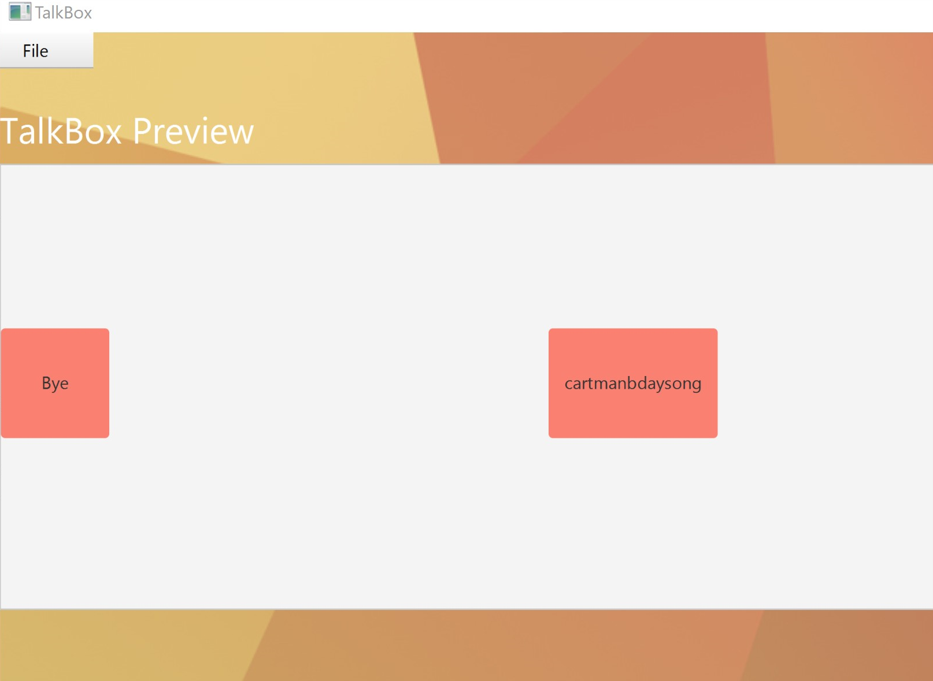

**Section 7 Trouble-Shoot**

**7.1 JAR**  
If the JAR file is unable to run do the following steps

1) Make sure the TalkBoxConfiguration JAR file is extracted. A visual can be seen below.

2)Make sure the extracted TalkBoxConfiguration directory is located in the same directory as its JAR file

3)Make sure you have JavaFX installed

**7.2) IDE**

1)Make sure there are no errors in the code